|  |
| --- |
| **PROJECT** |
| **CLOUD FRONT** |
|  |
|  |
|  |
|  |
|  |
|  |

CloudFront

**AIM**

Creating a CloudFront CDN Distribution to distribute a set of images

**PREREQUSITE**

Basic knowledge of s3

**STEPS**

[Step 1: Sign up for Amazon Web Services](http://docs.aws.amazon.com/AmazonCloudFront/latest/DeveloperGuide/GettingStarted.html#GettingStartedSignup)

[Step 2: Upload your content to Amazon S3 and grant object permissions](http://docs.aws.amazon.com/AmazonCloudFront/latest/DeveloperGuide/GettingStarted.html#GettingStartedUploadContent)

Sign in to the AWS Management Console and open the Amazon S3 console at <https://console.aws.amazon.com/s3/>.

In the Amazon S3 console, choose Create Bucket.

In the Create Bucket dialog, enter a bucket name..

1. Choose **Create**.
2. Select your bucket in the **Buckets** pane, and choose **Upload**.
3. On the **Upload - Select Files** page, choose **Add Files**, and choose the files that you want to upload.
4. Enable public read privileges for each object that you upload to your Amazon S3 bucket.
   1. Choose **Set Details**.
   2. On the **Set Details** page, choose **Set Permissions**.
   3. On the **Set Permissions** page, choose **Make everything public**.
5. Choose **Start Upload**.

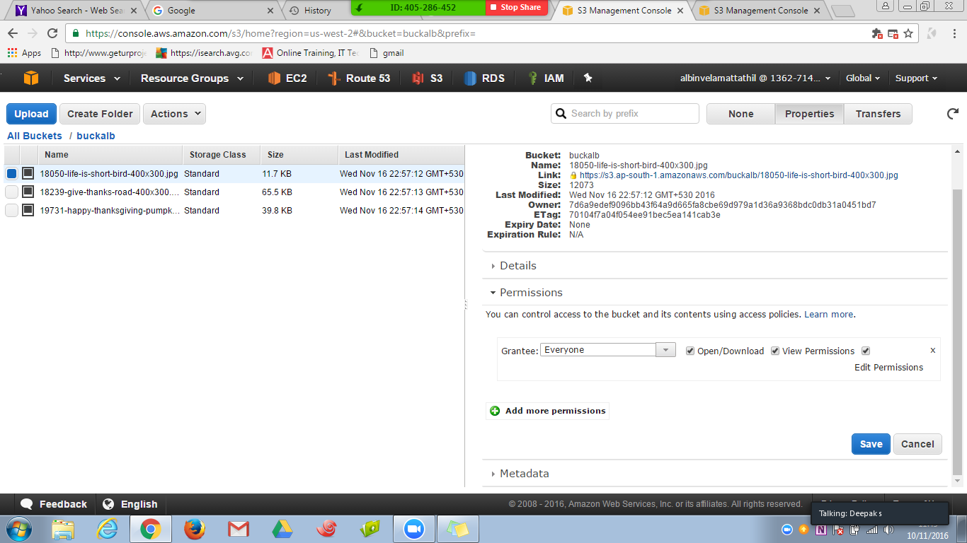

**Step 3: Create a CloudFront Web Distribution**

**To create a CloudFront web distribution**

1. Open the CloudFront console at <https://console.aws.amazon.com/cloudfront/>.
2. Choose **Create Distribution**.
3. On the **Select a delivery method for your content** page, in the **Web** section, choose **Get Started**.
4. On the **Create Distribution** page, under **Origin Settings**, choose the Amazon S3 bucket that you created earlier. For **Origin ID**, **Origin Path**, **Restrict Bucket Access**, and **Origin Custom Headers**, accept the default values.

5. Under **Default Cache Behavior Settings**, accept the default values, and CloudFront will:

* Forward all requests that use the CloudFront URL for your distribution (for example, http://d111111abcdef8.cloudfront.net/image.jpg) to the Amazon S3 bucket that you specified in Step 4.
* Allow end users to use either HTTP or HTTPS to access your objects.
* Respond to requests for your objects.
* Cache your objects at CloudFront edge locations for 24 hours.
* Forward only the default request headers to your origin and not cache your objects based on the values in the headers.
* Exclude cookies and query string parameters, if any, when forwarding requests for objects to your origin. (Amazon S3 doesn't process cookies and processes only a limited set of query string parameters.)
* Not be configured to distribute media files in the Microsoft Smooth Streaming format.
* Allow everyone to view your content.
* Not automatically compress your content.

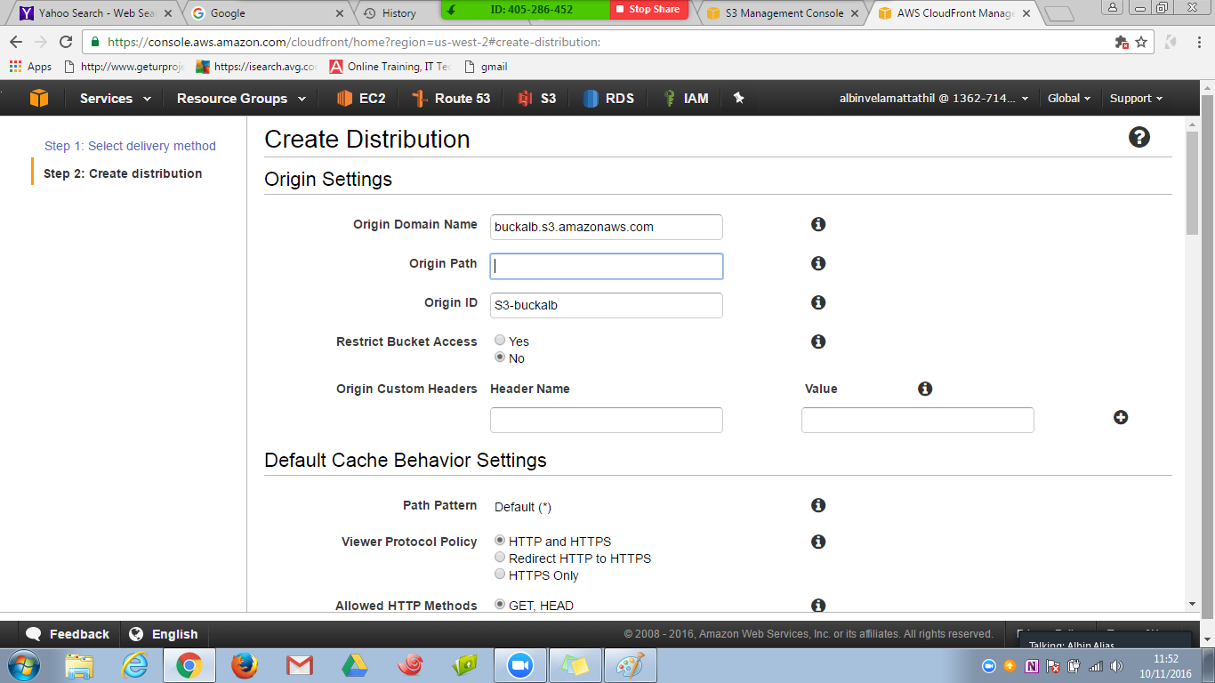

7.Choose **Create Distribution**.

* After CloudFront has created your distribution, the value of the **Status** column for your distribution will change from **InProgress** to **Deployed**. If you chose to enable the distribution, it will then be ready to process requests
* 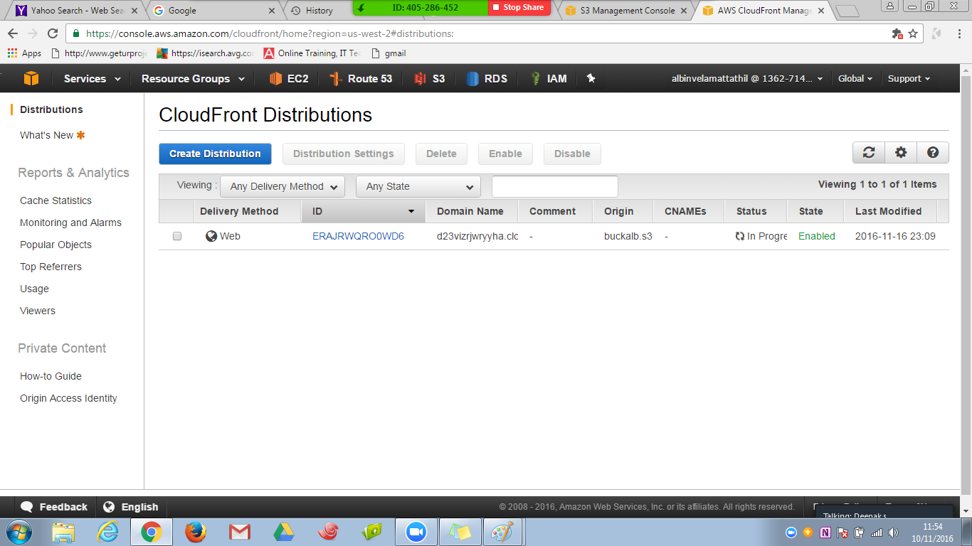

## Step 4: Test your links

After you've created your distribution, CloudFront knows where your Amazon S3 origin server is, and you know the domain name associated with the distribution. You can create a link to your Amazon S3 bucket content with that domain name, and have CloudFront serve it.

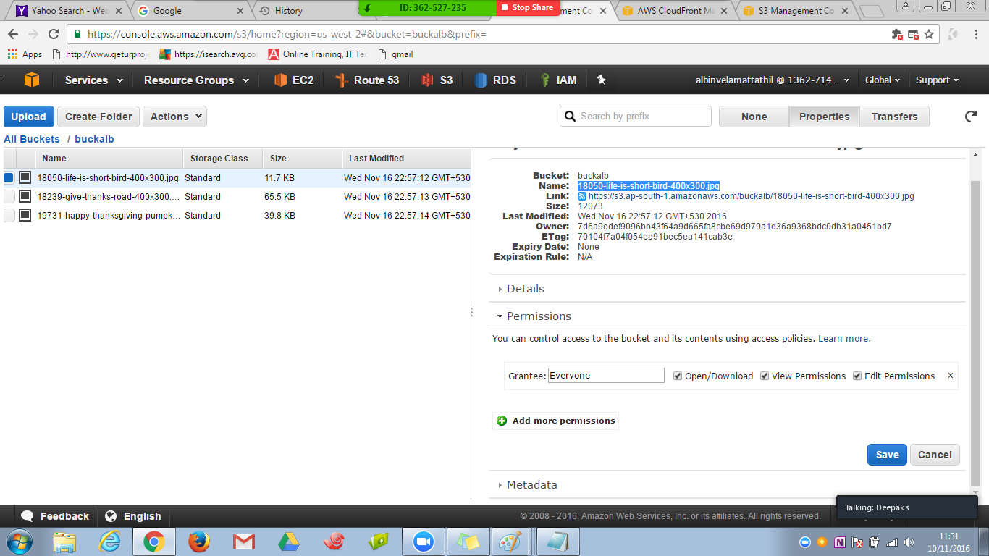

.

**To link to your objects**

1. Copy the following HTML into a new file:
   * Replace <domain name> with the domain name that CloudFront assigned to your distribution.
   * Replace <object name> with the name of a file in your Amazon S3 bucket
2. <html>
3. <head>My CloudFront Test</head>
4. <body>
5. <p>My text content goes here.</p>
6. <p><imgsrc="http://*domain name*/*object name*" alt="my test image"/>
7. </body>
8. </html>
9. Save the text in a file that has a .html filename extension.
10. Open your web page in a browser to ensure that you can see your content.

The browser returns your page with the embedded image file, served from the edge location that CloudFront determined was appropriate to serve the object.

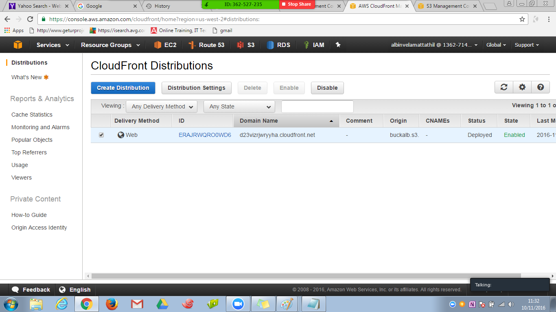

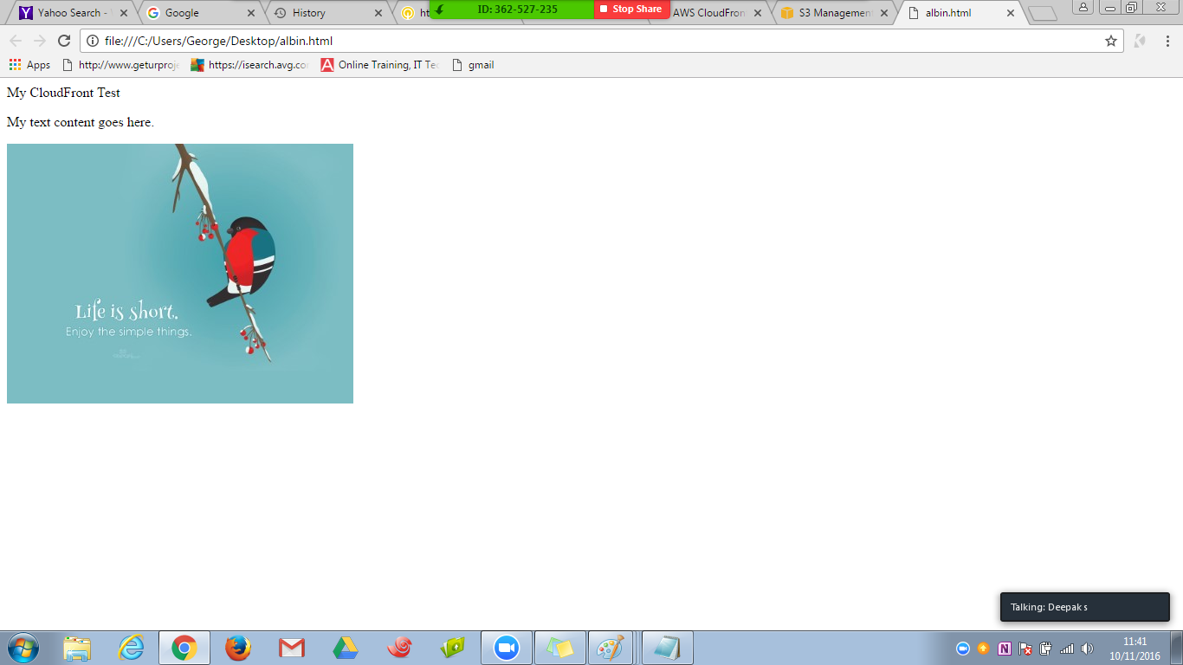

RESULT

Uploaded an image to s3 and Distributed the image uploaded using CDN across US,Canada and Europe